Residential green space and seasonal distress in a cohort of tree pollen allergy patients
Supplementary Information
Table S1. Observed average distress (GHQ-12 score) (95% confidence interval) and inferred average distress (95% credible interval) in a panel of 88 allergy patients residing in Flanders (Belgium) during the airborne pollen seasons of 2017 and 2018 stratified by residential green space characteristics and physical activity level. The significance values are from the Welch's unequal variances t-test, comparing observed and inferred average distress of subgroups with average distress reported by the general population in Flanders (1.5 [95% CI 1.4–1.7], n = 2,467).
 | GHQ-12
Predictor (n) | Observed mean | P | Inferred mean | P
Proximity to allergenic tree species  not present (22)  present (66) | 1.86 (1.37–2.53)  2.15 (1.83–2.54) | 0.072  0.464 | 1.75 (1.26–2.32)  2.10 (1.77–2.46) | 0.01  <0.001
High green (P50 = 54.5 ha)  < P50 (44)  ≥ P50 (44) | 2.55 (1.69–3.40)  1.61 (0.86–2.37) | 0.019  0.775 | 2.46 (2.02–2.93)  1.57 (1.22–1.95) | <0.001  0.390
Low green (P50 = 70.0 ha)  < P50 (44)  ≥ P50 (44) | 2.66 (1.69–3.62)  1.50 (0.91–2.09) | 0.021  1.000 | 2.57 (2.12–3.05)  1.46 (1.13–1.83) | <0.001  0.622
Physical activity  (20 minutes or more)  ≤ 1×20’/week (18)  > 1×20’/week (70) | 3.06 (1.45–4.66)  1.83 (1.24–2.42) | 0.057  0.285 | 2.80 (2.12–3.58)  1.79 (1.50–2.11) | <0.001  <0.001

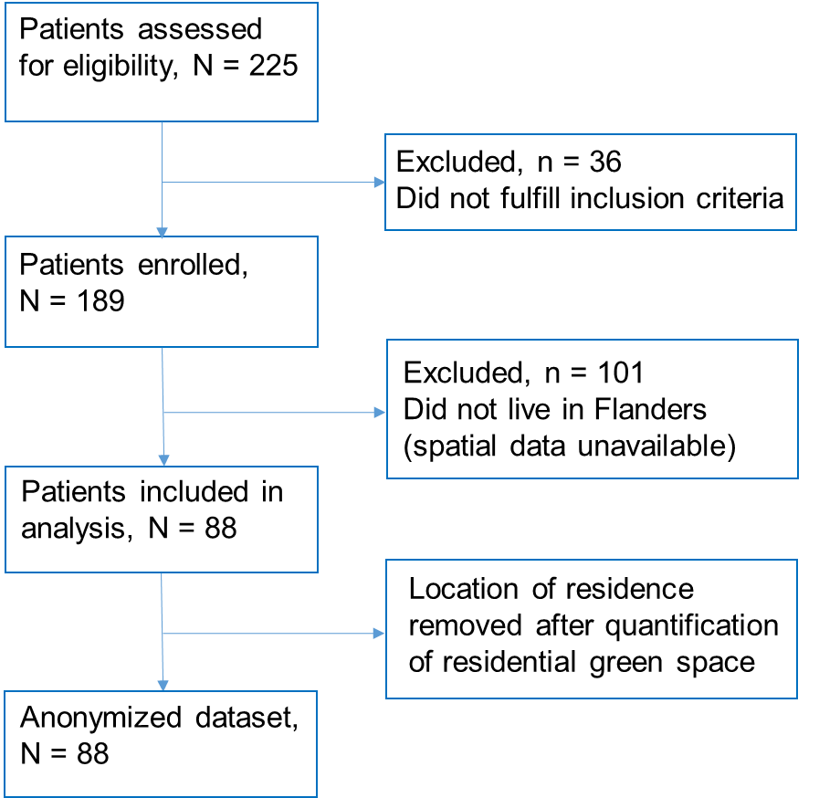

Figure S1. Flow diagram of the allergy patients included and excluded in the panel study.

Figure S2. Distribution of the residences of the 88 participants of the RespirIT study that were included in the panel study. Residence symbols do not match exact locations due to privacy restrictions. Green cover type data: Groenkaart Vlaanderen 2012 (available online at: http://www.geopunt.be/). The central white gap is the Brussels Capital Region, which was excluded from the present study because of missing green cover type data.

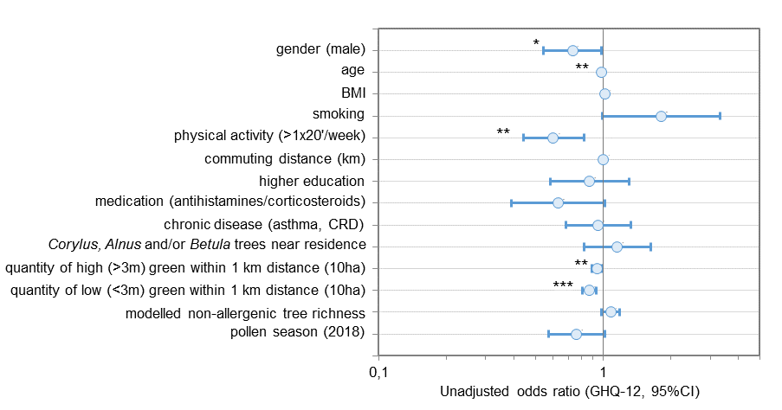

Figure S3. Unadjusted associations (odds ratios with 95% Wald confidence limits) between potential predictors and short-term distress (GHQ-12 score) in a cross-sectional sample of 88 pollen allergy patients in Flanders (Belgium) during the airborne tree pollen seasons of 2017 and 2018 from multivariable generalized linear models based on the Poisson probability distribution and a log-link function (* P<0.05; ** P<0.01; *** P<0.001).

